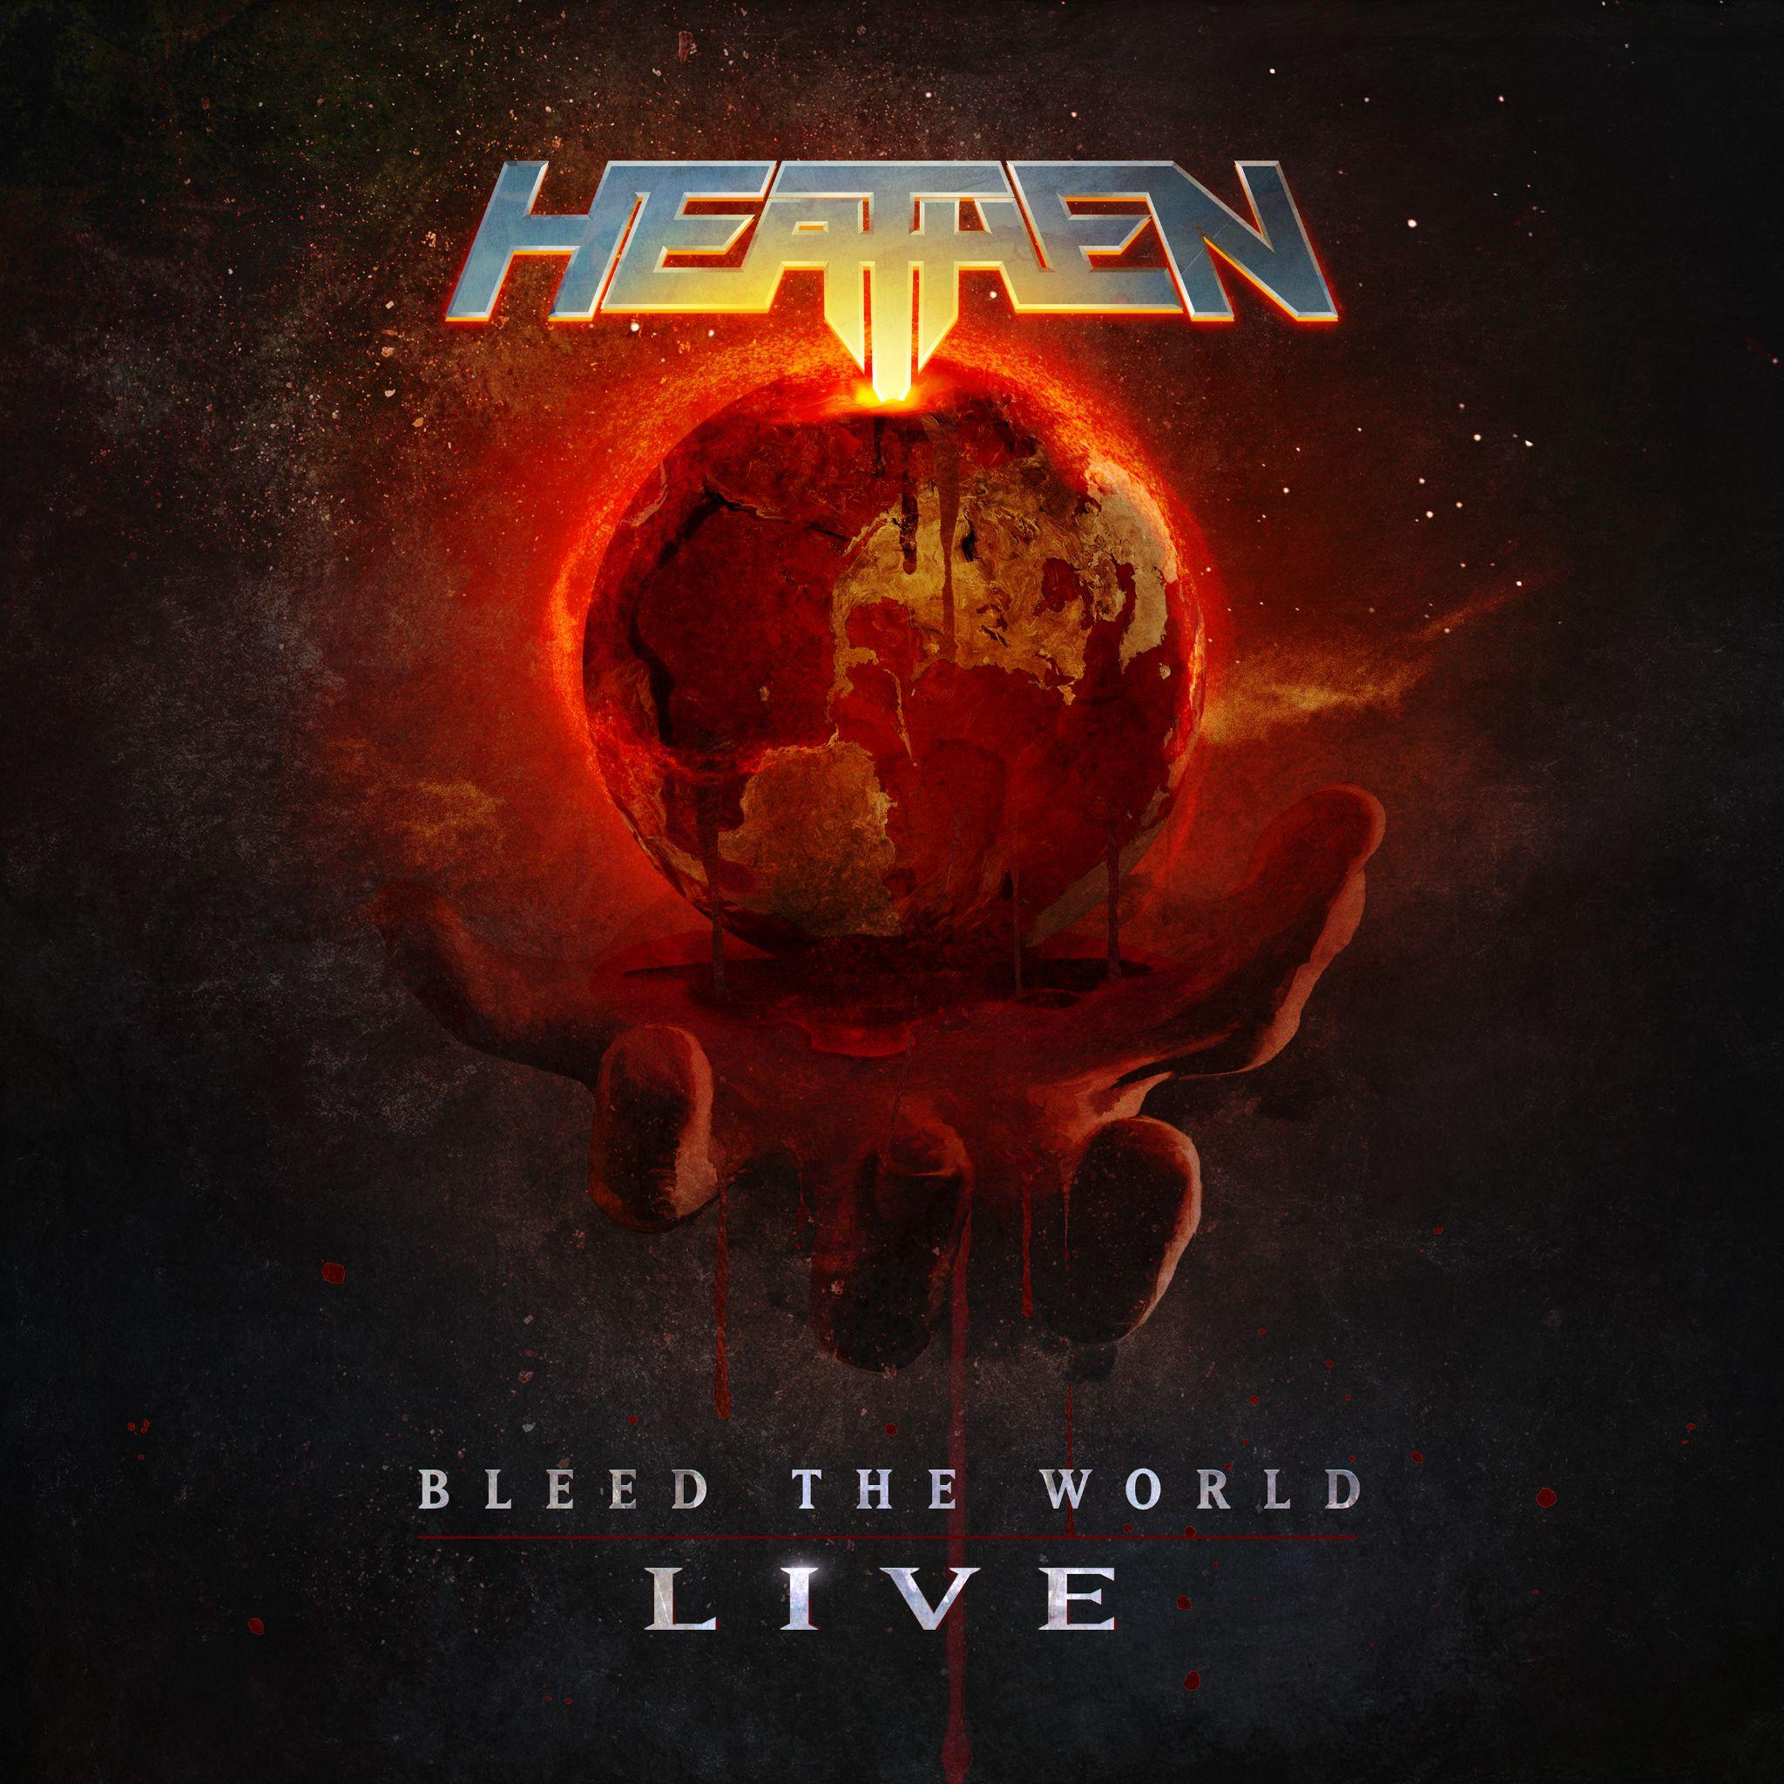

**HEATHEN**

*Bleed The World: Live*

*Release Date: March 14, 2025*

| **Line up:** | **HEATHEN online:** |
| --- | --- |
| **David White | Vocals**  **Kragen Lum | Guitars**  **Kyle Edissi | Guitar**  **Jason Mirza | Bass**  **Ryan Idris | Drums** | www.facebook.com/heathen.official/  www.instagram.com/heathenthrash  www.x.com/heathenmetal  www.youtube.com/@HeathenMetal |
|  |  |

For the past 40 years, the venerated Thrash Metal outfit **HEATHEN** have abided by their never-say-die attitude. Formed in 1984 in San Francisco’s Bay Area—home to EXODUS, METALLICA, TESTAMENT, and DEATH ANGEL —**HEATHEN** quickly separated themselves from the pack by expertly fusing **David White**’s distinctive vocals with a melody-driven and forward-thinking musical style. The band’s first two albums, ***Breaking the Silence*** and ***Victims of Deception***, are widely regarded as Bay Area Thrash classics. The **HEATHEN** brand of intelligent yet aggressive Thrash appealed not only to the genre’s core demographic, but also Metal fans looking for brains behind the brawn. The most recent full-length album, ***Empire of the Blind***, continued to push the boundaries of the genre, expanding their audience while restoring faith in vicious yet brainy Thrash Metal, the very kind that put **HEATHEN** on the map.

Since the release of their last album, ***Empire of the Blind***, **HEATHEN** has toured nonstop, playing hundreds of shows across 5 continents. From the moment that the COVID restrictions lifted in 2022, the band hit the ground running, touring with contemporaries such as TESTAMENT, EXODUS, OVERKILL, and SYMPHONY X over the last 3 years. Recorded in several cities across the United States during the 2023 Bleed the World Tour, ***Bleed the World: Live*** is the perfect audio representation of the **HEATHEN** live show. Featuring songs from each of the band’s albums, including recent tracks such as ‘**Sun in My Hand**’ and ‘**The Blight**’ as well as classics such as ‘**Hypnotized**’ and ‘**Goblin’s Blade**,’ the live album mirrors the band’s crushing live set list. The cover artwork by **Travis Smith** depicts a steel **HEATHEN** logo piercing the bleeding Earth, held by a hand that encapsulates the world tour as a moment in time. Produced by guitarist **Kragen Lum** and mixed by **Zeuss**, ***Bleed the World: Live*** transports the listener into the concert hall with a crystal-clear yet heavy production and captures the interaction between band and audience that makes every **HEATHEN** live show special.